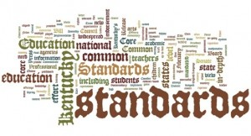
The East End Consortia for the Study of
Geometry and Algebra 2

The goal of these two activities is to provide a format and time for East End Teachers to collaborate on the ongoing rollout of the New York State “Story of Functions” Curriculum, NYS CORE standards, the NYSED curriculum modules, PARCC’s Model Content Framework, and best practices for implementing all of the above. It is not expected that each District will follow the same curriculum or envision the same pathway to implement the standards, but all of our schools are facing the same challenges in understanding the rigors of CORE Standards, the frameworks for which the state assessments will be aligned. Our quest is to help each other become more successful in filling the gaps in students’ knowledge in order to improve student achievement.
WHERE: Peconic Teacher Center 8:30-2:30
Meeting Dates Algebra 2 | Meeting Dates Geometry
12/18 | 11/20
2/26 | 1/15
4/15 | 3/18
TBA | 5/20
To register for the first meeting, please click on the following link https://www.mylearningplan.com/webreg/catalog.asp?H=1&D=10096
Each meeting will be listed separately as the year progresses. The Consortium will set the agenda to meet the needs of participants. Guest presenters will also be invited.

